EXPERIMENT NO:1

AIM:Introdution to computer hardware;physical identification of major components of a computer system such as mother board,RAM modules,daughtercards,busslots,SMPS,internalstorage devices,interfacing ports.

MOTHER BOARD

A motherboard is one of the most essential parts of a computer system. It holds together many of the crucial components of a computer, including the central processing unit (CPU), memory and connectors for input and output devices. The base of a motherboard consists of a very firm sheet of non-conductive material, typically some sort of rigid plastic. Thin layers of copper or aluminum foil, referred to as traces, are printed onto this sheet. These traces are very narrow and form the circuits between the various components. In addition to circuits, a motherboard contains a number of sockets and slots to connect the other components.

The motherboard houses the following components:
- Central Processing Unit (CPU) – performs all basic arithmetic, logical, control, and input/output operations
- Chipset – manages the data flow between the computer’s processor, its memory and any peripheral devices attached
- Buses – a pathway that transfers data between components within a computer
- Random Access Memory (RAM) – a temporary form of computer data storage that allows fast access to data. RAM is volatile and requires power to keep data accessible.
- Expansion slots – provide expansion capability to add hardware components beyond what was originally installed
- Ports – provides an interface between the computer and a peripheral device such as a mouse, keyboard, or printer

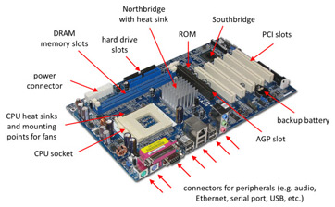

RAM MODULES

A memory module is another name for a RAM chip. It is often used as a general term used to describe SIMM, DIMM, and SO-DIMM memory. While there are several different types of memory modules available, they all serve the same purpose, which is to store temporary data while the computer is running.
Memory modules come in different sizes and have several different pin configurations. For example, the original SIMMs had 30 pins (which are metal contacts that connect to the motherboard). However, newer SIMM chips have 72 pins. DIMMs commonly come in 168-pin configurations, but some DIMMs have as many as 240 pins. SO-DIMMs have a smaller form factor than standard DIMM chips, and come in 72-pin, 144-pin, and 200-pin configurations.
While "memory module" is the technical term used to describe computer memory, the terms "RAM," "memory," and "RAM chip" are just as acceptable. But remember, while memory terms may be interchangeable, the memory itself is not. This is because most computers only accept one type of memory. Therefore, if you decide to upgrade you computer's RAM, make sure the memory modules you buy are compatible with your machine.

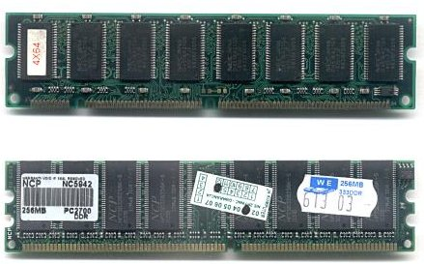

DAUGHTER CARDS

A daughterboard, sometimes also called a daughtercard or mezzanine board, is a part of a computer’s internal circuitry that is usually intended to improve or enhance the machine’s overall functioning, perhaps most significantly when it comes to available memory and operating speed. Most of the time this piece is not essential to the computer’s operation, and is normally added after market as an improvement or upgrade. It’s usually somewhat small and gets its name from its proximity to the larger and more crucial motherboard: the daughter component usually attaches onto the motherboard, which is a vital piece of most operating systems, and either improves it or offers it new functionality.

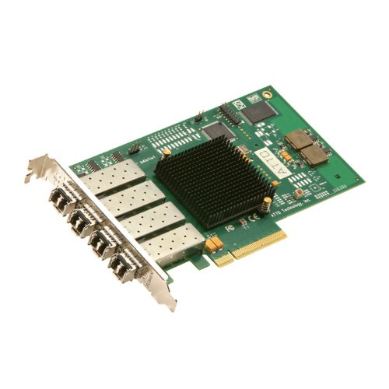
BUS SLOTS

Alternatively known as a bus slot or expansion port, an expansion slot is a connection or port inside a computer on the motherboard or riser card. It provides an installation point for a hardware expansion card to be connected. For example, if you wanted to install a new video card in the computer, you'd purchase a video expansion card and install that card into the compatible expansion slot.

Computer expansion slots
Below is a listing of expansion slots commonly found in a computer and the devices associated with those slots. Clicking any of the links below provide you with additional details.
- AGP-Vedio card.
- AMR - Modem,Sound card.
- CNR - Modem, network card, sound card.
- EISA -SCSI , network card, video card.
- ISA - Network card, sound card, video card.
- PCI - Network card, SCSI, sound card, video card.
- PCI EXPRESS - Video card, modem, sound card, network card.
- VESA - Video card.
Many of the expansion card slots above are obsolete. You're most likely only going to encounter AGP, PCI, and PCI Express when working with computers today. The picture below is an example of what expansion slots may look like on a motherboard. In this picture, there are three different types of expansion slots: PCI Express, PCI, and AGP
. 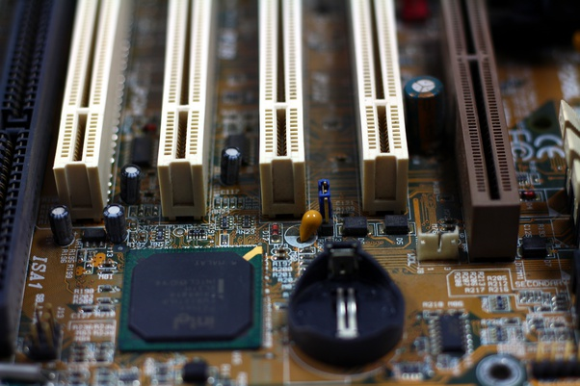
SMPS(Switched Mode Power Supply)

SMPS is the Switched Mode Power Supply circuit which is designed for obtaining the regulated DC output voltage from an unregulated DC or AC voltage. There are four main types of SMPS such as
- DC to DC Converter
- AC to DC Converter
- Fly back Converter
- Forward Converter
The AC to DC conversion part in the input section makes the difference between AC to DC converter and DC to DC converter. The Fly back converter is used for Low power applications. Also there are Buck Converter and Boost converter in the SMPS types which decrease or increase the output voltage depending upon the requirements. The other type of SMPS include Self-oscillating fly-back converter, Buck-boost converter, Cuk, Sepic, etc.

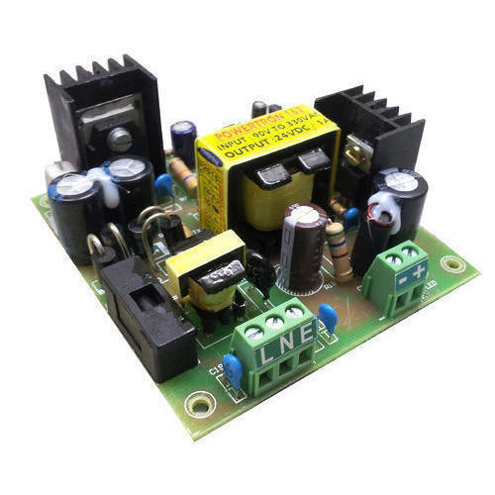

INTERNAL STORAGE DEVICES

Some storage devices are classed as 'internal' which means they are inside the computer case.

Most computers have some form of internal storage. The most common type of internal storage is the hard disk.

hard disk

At the most basic level, internal storage is needed to hold the operating system so that the computer is able to access the input and output devices.

It will also be used to store the applications software that you use and more than likely, the original copies of your data files.

Internal storage allows the data and applications to be loaded very rapidly into memory, ready for use. The data can be accessed much faster than data which is stored on an external storage device. This is because internal storage devices are connected directly to the motherboard and its data bus whereas external devices are connected through a hardware interface such as USB, which means they are considerably slower to access.

Internal storage also means that if the computer is moved around, it will still retain its most commonly used data.

The main disadvantage of internal storage is that when the hard disk fails (and it will), all the data and applications may be lost.

This can be avoided to some extent by using more than one hard disk within the machine. Each hard disk has a copy of all the data, so if one fails the other can carry on. This is called a RAID array. An alternative is to use external drives for backup

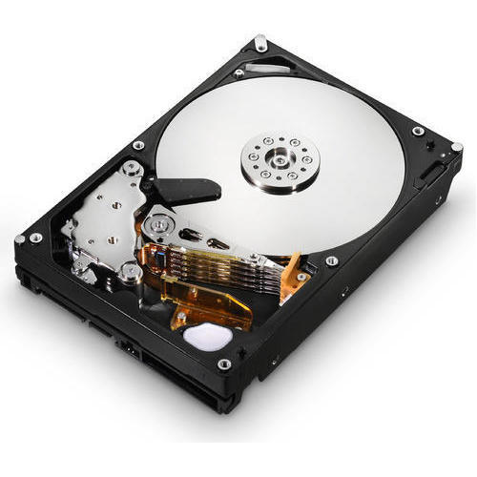

INTERFACING PORTS

A port is a physical docking point using which an external device can be connected to the computer. It can also be programmatic docking point through which information flows from a program to the computer or over the Internet.

Characteristics of Ports
A port has the following characteristics −

- External devices are connected to a computer using cables and ports.
- Ports are slots on the motherboard into which a cable of external device is plugged in.
- Examples of external devices attached via ports are the mouse, keyboard, monitor, microphone, speakers, etc.

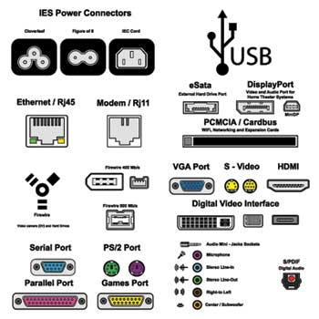

Let us now discuss a few important types of ports −
Serial Port

- Used for external modems and older computer mouse
- Two versions: 9 pin, 25 pin model
- Data travels at 115 kilobits per second

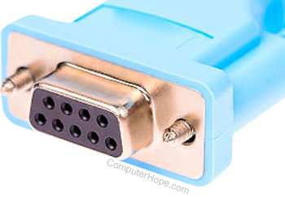

Parallel Port

- Used for scanners and printers
- Also called printer port
- 25 pin model
- IEEE 1284-compliant Centronics port

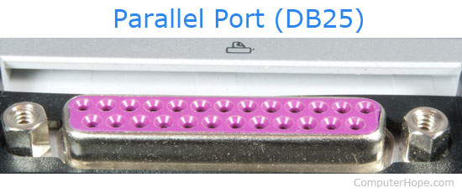

PS/2 Port

- Used for old computer keyboard and mouse
- Also called mouse port
- Most of the old computers provide two PS/2 port, each for the mouse and keyboard
- IEEE 1284-compliant Centronics port

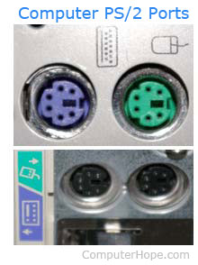

Universal Serial Bus (or USB) Port

- It can connect all kinds of external USB devices such as external hard disk, printer, scanner, mouse, keyboard, etc.
- It was introduced in 1997.
- Most of the computers provide two USB ports as minimum.
- Data travels at 12 megabits per seconds.
- USB compliant devices can get power from a USB port

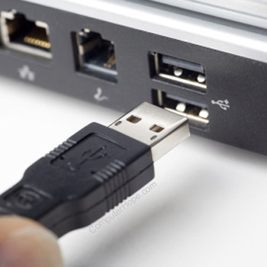

VGA Port

- Connects monitor to a computer's video card.
- It has 15 holes.
- Similar to the serial port connector. However, serial port connector has pins, VGA port has holes.
- Power Connector
- Three-pronged plug.
- Connects to the computer's power cable that plugs into a power bar or wall socket.

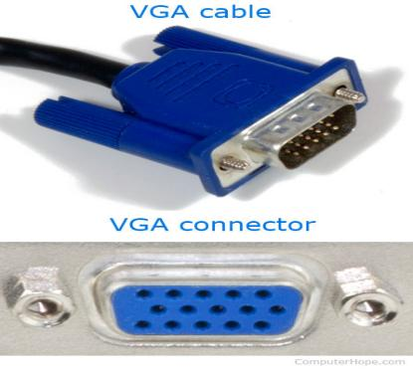

Firewire Port

- Transfers large amount of data at very fast speed.
- Connects camcorders and video equipment to the computer.
- Data travels at 400 to 800 megabits per seconds.
- Invented by Apple.
- It has three variants: 4-Pin FireWire 400 connector, 6-Pin FireWire 400 connector, and 9-Pin FireWire 800 connector.

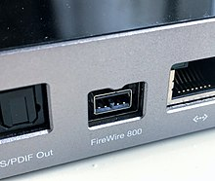

Modem Port
- Connects a PC's modem to the telephone network.
- Ethernet Port
- Connects to a network and high speed Internet.
- Connects the network cable to a computer.
- This port resides on an Ethernet Card.
- Data travels at 10 megabits to 1000 megabits per seconds depending upon the network bandwidth.

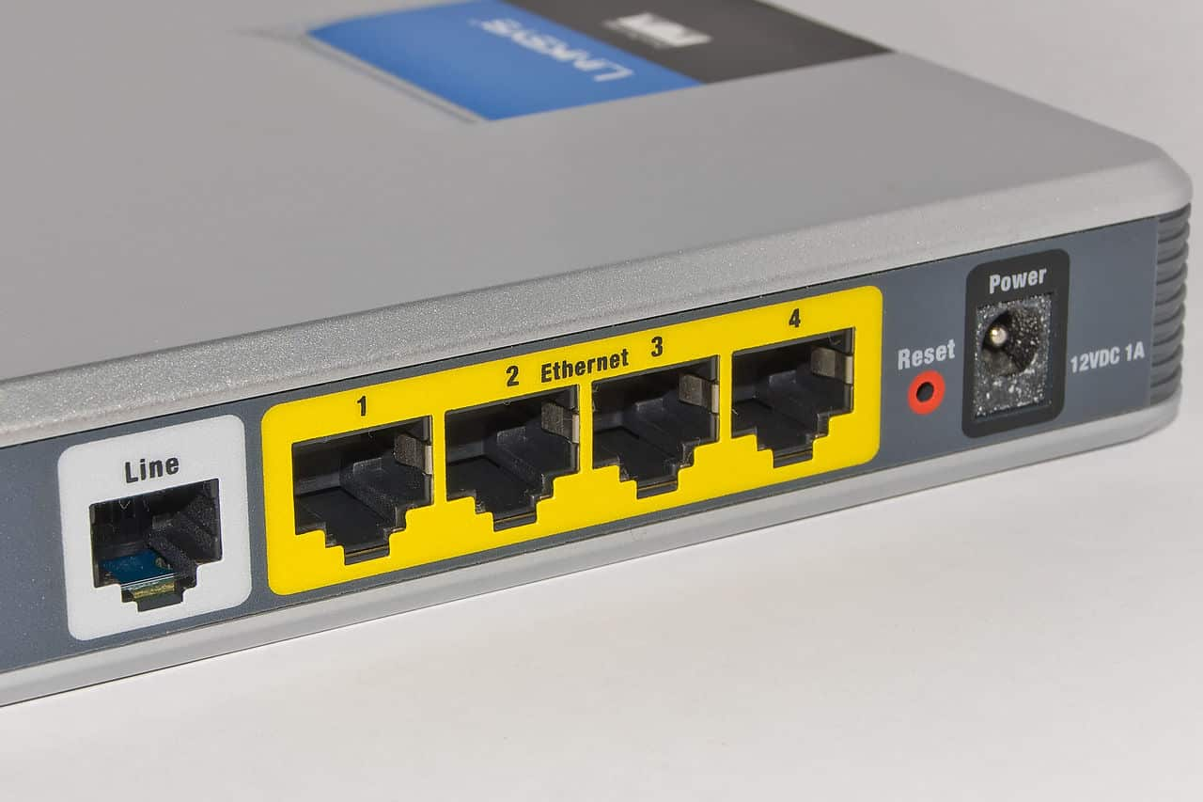
Game Port

- Connect a joystick to a PC
- Now replaced by USB
- Digital Video Interface, DVI port
- Connects Flat panel LCD monitor to the computer's high-end video graphic cards.
- Very popular among video card manufacturers.

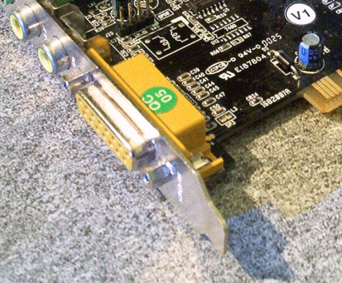

Digital Video Interface, DVI port
- Connects Flat panel LCD monitor to the computer's high-end video graphic cards.
- Very popular among video card manufacturers.

